ESP32-CAM Camera Module + Circuit Explanation
The ESP32-CAM is a very competitive small-size camera module that can run independently as a minimum system, with deep-sleep current as low as 6 mA. The ESP32-CAM can be widely used in various Internet of Things applications, including smart home devices, industrial wireless control, wireless monitoring, QR wireless identification, and wireless positioning systems. It is an ideal solution for IoT applications. This module supports image capture with the camera and Wi-Fi upload.
Features:
(1) Ultra-small 802.11b/g/n Wi-Fi + BT/BLE SoC module.
(2) Low-power dual-core 32-bit CPU suitable for application processors
(3) Up to 240 MHz and up to 600 DMIPS
(4) Built-in 520 KB SRAM and external 4 MB PSRAM
(5) Supports UART/SPI/I2C/PWM/ADC/DAC and other interfaces
(6) Supports OV2640 and OV7670 cameras with built-in flash support.
(7) Supports image upload over Wi-Fi and supports TF cards.
(8) Supports multiple sleep modes.
(9) Embedded LwIP and FreeRTOS.
(10) Supports STA/AP/STA+AP operating modes.
(11) Supports SmartConfig/AirKiss one-click network distribution.
(12) Supports serial local upgrade and remote firmware upgrade (FOTA).
The module interface circuit diagram and physical picture are shown below.
Module interface schematic
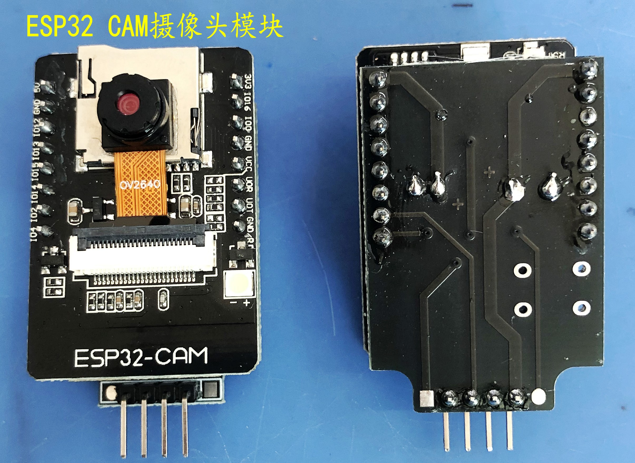
Module physical picture

